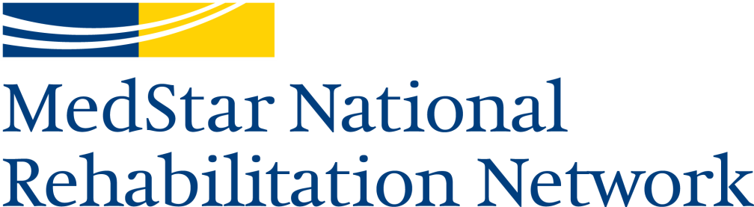
Transitions Neurological Day Treatment Program
102 Irving Street, NW
Washington, DC 20010
202-877-1439

Transitions Neurological Day Treatment Program Application
To initiate a referral, please complete this form and fax all indicated information to
program administrator Claudia Guzman at 202-291-2836.
Date: ______________
Patient name: _________________________________ Date of birth: ________________ Age: ______
Diagnosis: _________________________________________________ Date of onset: _____________
Inpatient rehab location & physician: ___________________________ Discharge date: _____________
Primary care physician: _____________________________________ Phone: ___________________
Insurance provider(s): _________________________________________________________________

Person applying on behalf of patient:
____________________________________________________________________________________
Name Relationship to patient Phone Email
Primary contact:
____________________________________________________________________________________
Name Relationship to patient Phone Email
Secondary contact:
____________________________________________________________________________________
Name Relationship to patient Phone Email
Does patient meet all listed admission criteria on page 2? yes no
If no, provide brief explanation: ________________________________________________________________________________________________________________________________________________________________________
Please attach the following documentation:
- Physician’s order for outpatient PT/OT/SLP/neuropsychology
- Demographics/insurance information
- Medical History and Physical (H&P) report
- Therapy notes and/or discharge summaries for physical therapy, occupational therapy, & speech language pathology
- Physician’s discharge summaries, when available
- Psychology/neuropsychology reports, if applicable
- Social work or case management reports, if applicable
Admission criteria for the Transitions Neurological Day Treatment Program:
- Diagnosis of moderate to severe brain injury (traumatic brain injury, stroke, brain tumor, anoxia, or other neurological dysfunction) within the past 12 months
- Age 14 years or older
- Medical stability and physician’s referral

- Has home and community re-entry goals (for example: medication/health management, managing finances, keeping track of appointments, being home alone safely, safely getting around public spaces, using public transportation, grocery shopping or running errands, full/part-time work/school/volunteering, etc.)
- Able to consistently participate and communicate in group activities and discussions
- Can understand simple sentences and express basic needs via a reliable mode of communication
- Able to change behavior when given direct feedback
- Can walk safely (with or without an assistive device, such as a walker, cane, rollator, crutch, etc.) with assistance for balance, if needed
OR if using a wheelchair, can propel self safely from place to place
- Able to get onto toilet without lifting assistance, and is independent with toilet hygiene
  - If more assistance is required in the bathroom, a caregiver must be present at all times
- Willing and able to tolerate at least 3 hours of therapy, plus travel time to and from the program, 3 – 5 days per week
- Continent during the daytime

- Insurance coverage, and/or other funding, for outpatient individual and group therapies
- Reliable transportation (family/friends, MetroAccess, public transportation)

Please note that patients who do not meet all of the above stated criteria will be considered on a case-by-case basis. A determination of program candidacy will be made once all documents have been received.

